**NEURAL NETWORK –ICP#1**

**Student Name:Dakul Phani Pavan Dasari**

**Student ID:700757709**

**Github LINK:** [**https://github.com/PAVAN1234567890145/ICP-1**](https://github.com/PAVAN1234567890145/ICP-1)

**Video Link:(shown in class)**

**QUESTION-1:** Write a python program for the following:

A) Input the string “Python” as a list of characters from console, delete at least 2 characters, reverse the resultant string and print it.

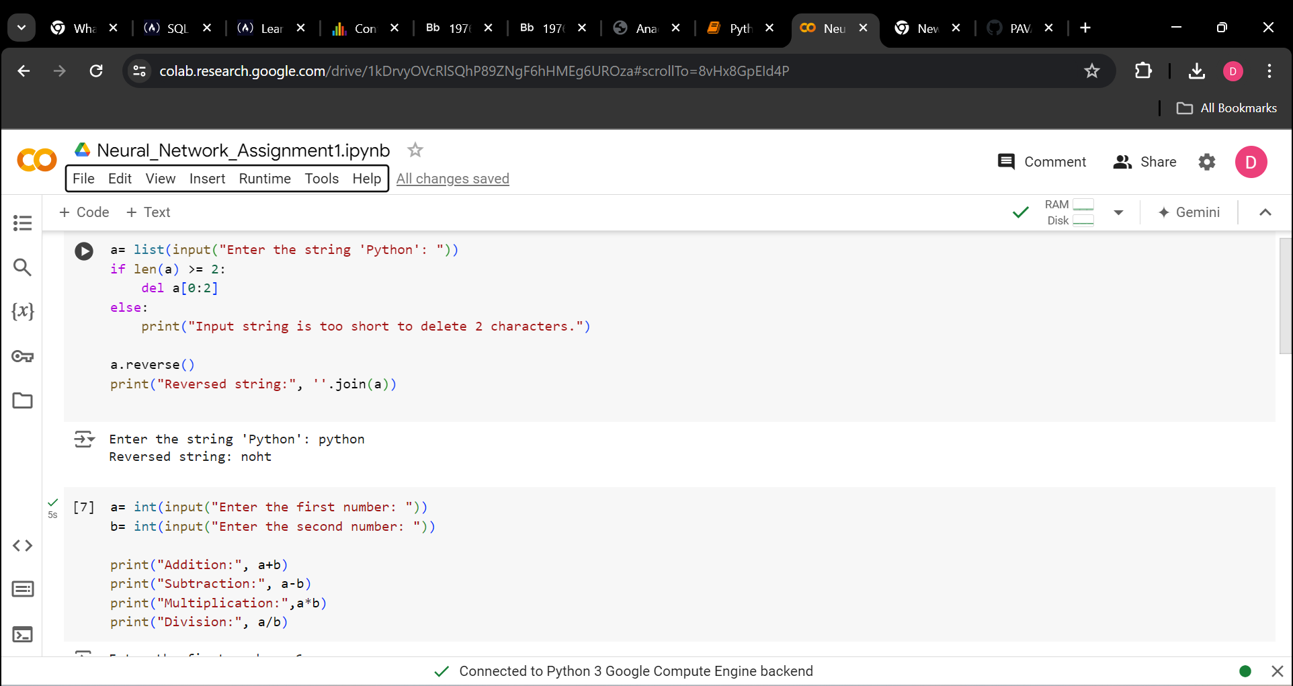

B) Take two numbers from user and perform at least 4 arithmetic operations on them.

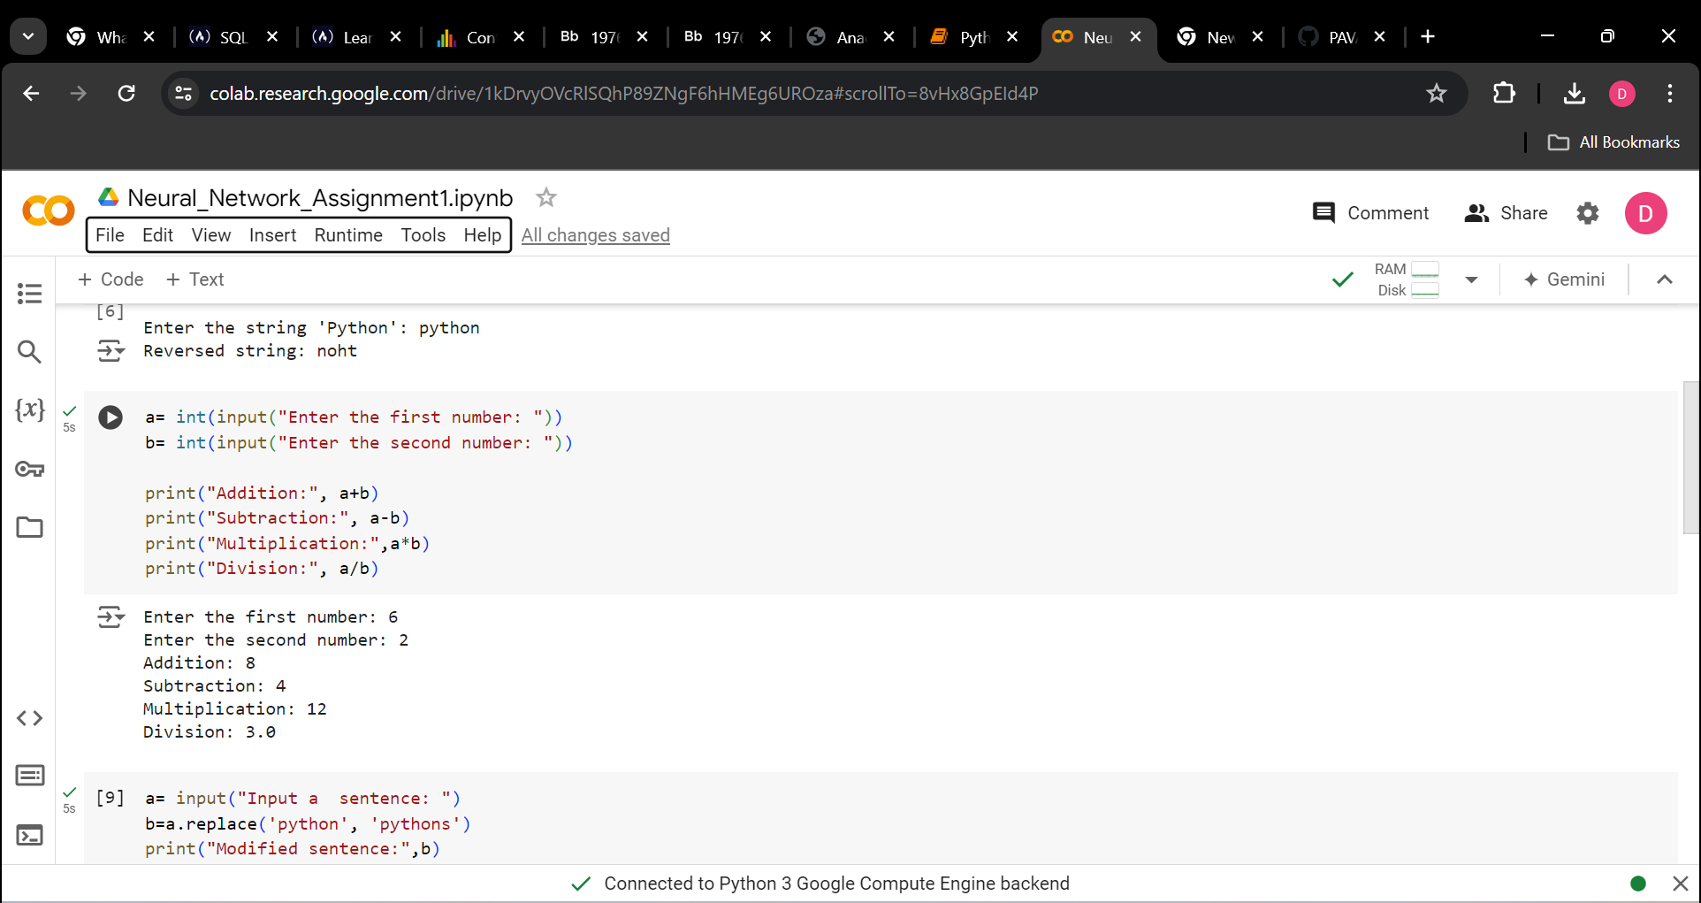

**QUESTION-2: Write** a program that accepts a sentence and replace each occurrence of ‘python’ with ‘pythons’.

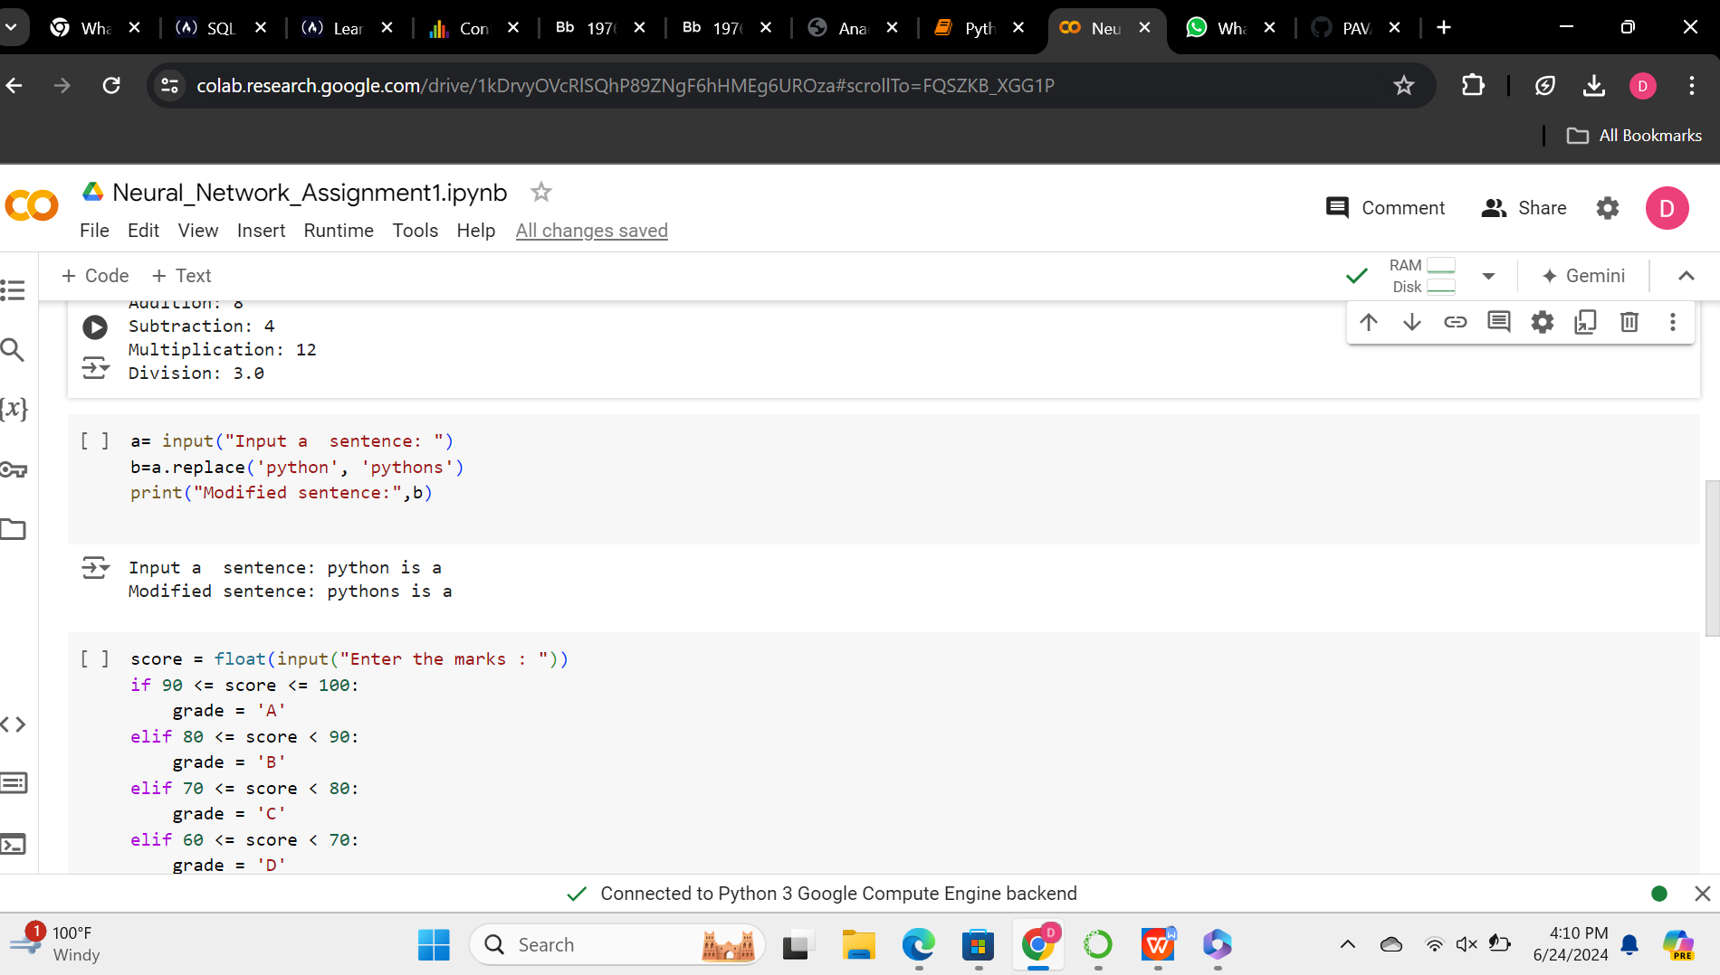

**QUESTION-3:** Use the if statement conditions to write a program to print the letter grade based on an input classscore. Use the grading scheme we are using in this class.

